**Project Design Phase-II**

**Data Flow Diagram & User Stories**

|  |  |
| --- | --- |
| Date | 05 November2022 |
| Team ID | **PNTIBMSm18** |
| Project Name | Emerging Methods for Early Detection of Forest Fires |
| Maximum Marks | 4 Marks |

# Data Flow Diagrams:

The traditional visual representation of how information moves through a system is a data flow diagram (DFD). A tidy and understandable DFD can graphically represent the appropriate amount of the system requirement. It demonstrates how information enters and exits the system, what modifies the data, and where information is kept.

# Example:

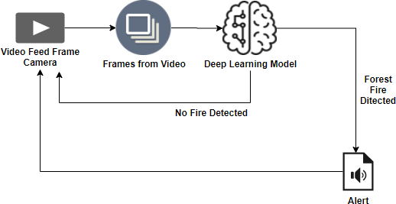

* In an under populated forest area, it is challenging to predict and detect forest fires.
* If the forecast is made using ground-based methods like camera or video-based approach, it is more complicated.
* Due to their reliability and efficiency, satellites can be a valuable source of data both prior to and during the Fire.
* the various methods for forecasting and detecting forest fires in real-time, with the aim of informing the local fire authorities.
* It will send the outcome to the frame camera if no fire is detected.

**DIAGRAM:**

VIDEO / IMAGES

CONVERT FRAMES FROM IMAGES/VIDEO

NO FIRE DETECTED

FIRE DETECTED

SMS ALERT

DEEP LEARNING MODEL(CNN)

**User stories:**

Use the below template to list all the user stories for the product.

|  |  |  |  |  |  |  |
| --- | --- | --- | --- | --- | --- | --- |
| **User Type** | **Functional Requirement**  **(Epic)** | **User Story Number** | **User Story / Task** | **Acceptance criteria** | **Priority** | **Release** |
| Environmentalist | Collect the data | USN-1 | It is necessary for an animal rights activist to gather information about forest fires. | We must collect the correct data.because of prediction. | High | Sprint-1 |
|  |  | USN-2 | Determine which algorithms can be used for prediction. | To gather the algorithms and determine each algorithm's  Accuracy. | Medium | Sprint-2 |
|  | Implement Algorithm | USN-3 | Determine each algorithm's accuracy. | Accuracy of the algorithm is must to be calculated. | High | Sprint-2 |
|  |  | USN-4 | Assess the data set. | Data is preprocessing  Before the training. | High | Sprint-1 |
|  | Evaluate Accuracy of Algorithm | USN-5 | Decide the precision, accuracy, as well as recall of each algorithm. | Accuracy is important to detect the severity of fire | High | Sprint-3 |